UNITED STATES
SECURITIES AND EXCHANGE COMMISSION
WASHINGTON, D.C. 20549

FORM 8-K

CURRENT REPORT
Pursuant to Section 13 or 15(d) of the Securities Exchange Act of 1934
Date of Report (Date of earliest event reported): June 04, 2026

X-Energy, Inc.
(Exact name of Registrant as Specified in Its Charter)

Delaware |  |  | 001-43246 | 41-3934505
(State or Other Jurisdiction  of Incorporation) |  |  | (Commission File Number) | (IRS Employer  Identification No.)
530 Gaither Road
Suite 700
Rockville, Maryland |  |  |  | 20850
(Address of Principal Executive Offices, including Zip Code) |  |  |  | (Zip Code)

Registrant’s Telephone Number, Including Area Code: 310 358-5600

(Former Name or Former Address, if Changed Since Last Report)

Check the appropriate box below if the Form 8-K filing is intended to simultaneously satisfy the filing obligation of the registrant under any of the following provisions:
☐Written communications pursuant to Rule 425 under the Securities Act (17 CFR 230.425)
☐Soliciting material pursuant to Rule 14a-12 under the Exchange Act (17 CFR 240.14a-12)
☐Pre-commencement communications pursuant to Rule 14d-2(b) under the Exchange Act (17 CFR 240.14d-2(b))
☐Pre-commencement communications pursuant to Rule 13e-4(c) under the Exchange Act (17 CFR 240.13e-4(c))
Securities registered pursuant to Section 12(b) of the Act:
Title of each class |  | Trading  Symbol(s) |  | Name of each exchange on which registered
Class A common stock, par value $0.0001 per share |  | XE |  | The Nasdaq Stock Market LLC
Indicate by check mark whether the registrant is an emerging growth company as defined in Rule 405 of the Securities Act of 1933 (§ 230.405 of this chapter) or Rule 12b-2 of the Securities Exchange Act of 1934 (§ 240.12b-2 of this chapter).
Emerging growth company ☒
If an emerging growth company, indicate by check mark if the registrant has elected not to use the extended transition period for complying with any new or revised financial accounting standards provided pursuant to Section 13(a) of the Exchange Act. ☐

1

Item 2.02 Results of Operations and Financial Condition.
On June 4, 2026, X-Energy, Inc. (the "Company") issued a press release reporting its financial results for the three months ended March 31, 2026. A copy of the press release, as well as a copy of the accompanying earnings presentation, are furnished as Exhibit 99.1 and Exhibit 99.2 hereto, respectively, and incorporated herein by reference.
The information in this Item 2.02, including Exhibit 99.1 and Exhibit 99.2, is furnished and shall not be deemed “filed” for purposes of Section 18 of the Securities Exchange Act of 1934, as amended (the “Exchange Act”), or otherwise subject to liabilities under that section, and shall not be deemed to be incorporated by reference into the filings of the Company under the Securities Act of 1933, as amended, or the Exchange Act, regardless of any general incorporation language in such filings, except as shall be expressly set forth by specific reference in such filing.

Item 7.01 Regulation FD Disclosure.

Expected Early Lock-Up Release Date
In connection with the public offering of the Class A common stock, par value $0.0001 per share (the “Common Stock”), of the Company, all of the Company's officers, directors, and substantially all of the Company’s holders of outstanding Common Stock were parties to lock-up agreements with the underwriters that restrict their ability to sell or transfer their shares, or otherwise engage in certain transactions related to their shares, for a period of 180 days after April 23, 2026, the date of the final prospectus relating to the public offering (the “Prospectus”), subject to certain exceptions. Such period is referred to as the “Restricted Period.”
Pursuant to the lock-up agreements with J.P. Morgan Securities LLC, as representative of the several underwriters (the “Representative”), the “Restricted Period will end ten trading days prior to the commencement of a blackout period if (i) at least 120 days have elapsed since the date of the Prospectus and (ii) the Restricted Period is scheduled to end during or within five trading days prior to a blackout period...” The Restricted Period is scheduled to end on October 20, 2026, which falls within the Company's quarterly blackout period. Therefore, under the lock-up agreements, the Restricted Period will end on September 1, 2026, ten trading days prior to the commencement of such blackout period, and the shares subject to the lock-up agreements will become eligible for sale in the public market (subject to any additional applicable trading limitations).
The information in this Item 7.01 is furnished and shall not be deemed “filed” for purposes of Section 18 of the Exchange Act, or otherwise subject to liabilities under that section, and shall not be deemed to be incorporated by reference into the filings of the Company under the Securities Act of 1933, as amended, or the Exchange Act, regardless of any general incorporation language in such filings, except as shall be expressly set forth by specific reference in such filing.
Item 9.01 Financial Statements and Exhibits.

(d) Exhibits
Exhibit No. |  | Description
99.1 |  | Press Release, dated June 4, 2026
99.2 |  | Earnings Presentation, dated June 4, 2026
104 |  | Cover Page Interactive Data File (formatted as inline XBRL).

2

SIGNATURES
Pursuant to the requirements of the Securities Exchange Act of 1934, the registrant has duly caused this report to be signed on its behalf by the undersigned hereunto duly authorized.

 |  |  | X-ENERGY, INC.
Date: | June 4, 2026 | By: | /s/ Daniel Gross
Name: Daniel Gross
Title: Chief Financial Officer

3

Exhibit 99.1

X-energy Reports First Quarter 2026 Results

•
Revenues and grant income of $43 million, compared to revenues and grant income of $21 million in 1Q 2025
•
Raised approximately $1.1 billion in net proceeds through initial public offering (“IPO”) and began trading on the Nasdaq Global Select Market (“Nasdaq”) under the ticker “XE”
•
Submitted application to enter the United Kingdom's Generic Design Assessment (“GDA”) process for its Xe-100 High Temperature Gas-cooled Reactor (“HTGR”)
•
Received U.S. Nuclear Regulatory Commission (“NRC”) Environmental Assessment for Dow’s advanced nuclear project in Seadrift, Texas in May, with a Finding of No Significant Impact (“FONSI”)
•
Received Part 70 fuel fabrication license from the NRC, enabling commercial manufacturing for TRISO-X fuel
•
Signed key supply agreement with SGL Carbon for graphite supply and MOU with IHI Corporation for critical HTGR components
•
Exploring deployment of Xe-100 small modular reactors (“SMRs”) with Louisville Gas and Electric Company (“LG&E”) and Kentucky Utilities Company (“KU”), subsidiaries of PPL Corporation, in Kentucky, and with Talen Energy in Pennsylvania and across the PJM Interconnection Regional Transmission Organization (“PJM”)

ROCKVILLE, Md., June 4, 2026 – X-Energy, Inc. (NASDAQ: XE) (“X-energy” or the “Company”), a leading designer of advanced nuclear reactor technology and manufacturer of nuclear fuels, today announced first quarter 2026 financial results for X-Energy Reactor Company, LLC, the predecessor company to X-Energy, Inc., and operational highlights.

“Our first earnings announcement as a public company marks an important moment for X-energy and reflects the progress we are making to commercialize advanced nuclear technology at scale,” said J. Clay Sell, CEO of X-energy. “During the first quarter of 2026, we remained focused on advancing the development of the Xe-100 and TRISO-X fuel, while continuing to strengthen the regulatory and commercial foundation needed to support long-term deployment.”

“This quarter’s regulatory achievements reflect the strength of X-energy’s long-term approach to licensing and regulatory engagement,” Sell continued. “As the industry works to bring advanced nuclear technologies to market, we believe our ability to achieve first-of-their-kind regulatory approvals helps to establish a stronger foundation for the future commercialization and deployment of advanced nuclear at scale. At the same time, we continued strengthening the commercial foundation of the business through strategic supply chain partnerships, preliminary agreements with domestic utilities, and continued construction of our TX-1 fuel facility in Tennessee.”

Daniel Gross, CFO of X-energy added, “Our recent IPO enhanced X-energy’s liquidity profile, providing approximately $1.1 billion dollars in net proceeds of additional capital as we work on bringing advanced nuclear technologies to market. Supported by our industry-leading customer base, our IPO further bolsters our leadership in SMR deployment and commercialization.”

Operational Highlights

•
Project Milestones: In May, the NRC completed its Environmental Assessment as part of Dow’s Construction Permit Application for the proposed advanced nuclear project in Seadrift, Texas. The NRC’s review was completed ahead of schedule following a comprehensive independent analysis, concluding with a FONSI. The project is being partially funded under the U.S. Department of Energy's Advanced Reactor Demonstration Program (“ARDP”) and would provide both electricity and high-temperature industrial steam to Dow’s UCC Seadrift Operations. Development efforts are also currently underway for the first Amazon-backed project with Energy Northwest.

•
TRISO-X Fuel and TX-1/TX-2: Received a Special Nuclear Material License under Part 70 from the NRC, enabling TRISO-X to commercially manufacture fuel using high-assay low-enriched uranium (“HALEU”) at its first two commercial facilities (“TX-1” and “TX-2”) under an initial 40-year license. Vertical construction for TX-1 in Oak Ridge, Tennessee is underway and the facility remains on schedule for completion by the first half of 2028. In addition, irradiation testing for the TRISO-X pebble fuel is in progress at Idaho National Laboratory in collaboration with the NRC.
•
Strategic Partners: Entered into a 10-year graphite supply agreement for reactor components of the Company’s Xe-100 SMR, which supports its first commercial deployment for Dow’s Seadrift project under ARDP and is expected to provide a foundation of supply for future projects. Additionally, the Company signed a Memorandum of Understanding with IHI Corporation, a leading nuclear-grade supplier for critical components used in X-energy’s HTGR, to explore opportunities for commercial-grade manufacturing of nuclear-grade components.
•
Business Development: Announced a collaboration with LG&E and KU, subsidiaries of PPL Corporation, to explore deploying Xe-100 SMRs in Kentucky to meet growing energy demand across the Commonwealth, and large load customers, including data centers. Early project feasibility activities have begun and could potentially be supported by the state’s Nuclear Reactor Site Readiness Pilot Program, which includes a $75 million grant initiative to support nuclear site feasibility studies, applications for early site and construction permitting, and licensing. Three projects are expected to be selected to receive up to $25 million each. The Company also recently signed a Letter of Intent with Talen Energy to assess deploying three or more four-unit Xe-100 plants in Pennsylvania and across the PJM market to add clean baseload capacity to help support reliability and meet growing energy demand from onshoring of manufacturing, data centers, and electrification. Under the agreement, X-energy and Talen plan to conduct early-stage project development activities, including feasibility studies, site evaluations, and a project execution framework.
•
Regulatory: Submitted an application to enter the U.K.'s GDA process for its Xe-100 HTGR to advance the Company's commercial partnership with Centrica. Subject to acceptance, this is the established regulatory pathway for licensing new nuclear technologies, evaluating safety, security, safeguards, and environmental impact independent of site-specific applications in the U.K.

Coordination with the NRC for review of a construction permit application for a proposed advanced nuclear project at The Dow Chemical Company’s UCC Seadrift, Texas site is ongoing. Dow and X-energy’s Construction Permit Application for the proposed advanced nuclear project in Seadrift, Texas, achieved a historic milestone as the first commercial reactor to receive environmental clearance through an Environmental Assessment instead of a years-long Environmental Impact Statement. Following a comprehensive independent analysis, the NRC completed its assessment ahead of schedule and issued a FONSI.
•
Corporate: On April 24, 2026, the Company began trading on Nasdaq under the ticker “XE” and on April 27, 2026, the Company closed its IPO, raising approximately $1.1 billion in net proceeds. The use of proceeds is intended for working capital and other general corporate purposes, which may include research and development and sales and marketing activities, general and administrative matters, and capital expenditures, including spending necessary for supply chain and procurement activities, in addition to potentially funding future growth projects.

1Q 2026 Financial Results
 |  | Three Months Ended March 31,
(Dollars in millions) |  | 2026 |  |  |  | 2025 |  |  |  | % Change
Total revenues and grant income |  | $ | 43.4 |  |  | $ | 20.8 |  |  |  | 109 | %
Total operating expenses |  |  | 109.5 |  |  |  | 47.1 |  |  |  | 133 | %
Net cash used in operating activities |  |  | (67.3 | ) |  |  | (41.9 | ) |  |  | 61 | %
Net cash used in investing activities |  |  | (166.0 | ) |  |  | (1.7 | ) |  |  | 9,602 | %
Net cash provided by (used in) financing activities |  |  | (1.1 | ) |  |  | 50.9 |  |  |  | (102 | )%

Total Revenues and Grant Income in the three months ended March 31, 2026 were $43.4 million, including $39.9 million of Services Revenue and $3.5 million of Grant Income. Total Revenues and Grant Income increased 109% compared to the three months ended March 31, 2025 primarily due to a $21.6 million increase in revenue and grant income from the

ARDP Agreement with the Department of Energy (“DOE”). This was driven by an increase in activities and nature of services performed.

Total Operating Expenses in the three months ended March 31, 2026 were $109.5 million, including $65.4 million of Direct Costs. Total Operating Expenses increased 133% compared to the three months ended March 31, 2025 primarily due to an increase of $36.6 million in Direct Costs and an increase of $26.1 million in Selling, General, and Administrative expenses. The increase in Direct Costs was driven by increases of $12.0 million and $11.7 million in subcontracting costs and direct materials, respectively, which were driven by an increase in activity related to the ARDP Agreement, and an increase of $11.4 million in direct labor costs which was driven by an increase in employee headcount to support activity under the ARDP Agreement. The increase in Selling, General, and Administrative expenses was primarily due to an $8.7 million increase in payroll-related costs due primarily to increases in employee headcount and a $3.1 million increase in unit-based compensation expense due to new grants made during the year ended December 31, 2025. Selling, General and Administrative expenses further increased by $6.1 million due to contractor costs related to corporate projects and a $5.2 million increase in professional fees and enterprise software costs for general corporate use.

Net Cash Used in Operating Activities in the three months ended March 31, 2026 was $67.3 million, a 61% increase compared to the three months ended March 31, 2025, primarily due to an increase in activity on the ARDP Agreement, an increase in corporate headcount, and an increase in enterprise software costs and corporate contractors.

Net Cash Used in Investing Activities in the three months ended March 31, 2026 was $166.0 million, reflecting $43.0 million of capital expenditures and $28.8 million of reimbursements for capital expenditures received from the DOE under the ARDP. The increase in Net Cash Used in Investing Activities compared to the three months ended March 31, 2025 was primarily due to purchases of investments of $189.9 million, and a $31.7 million increase in capital expenditures related to the construction of facilities, including TX-1. These increases in cash outflows were partially offset by a $38.1 million increase in proceeds from investment maturities and a $19.3 million increase in reimbursements received during the period for capital expenditures qualifying under government grant programs compared to the three months ended March 31, 2025.

1Q 2026 Liquidity
(Dollars in millions) |  | March 31, 2026 |  |  |  | December 31, 2025 |  |  |  | % Change
Cash and cash equivalents |  | $ | 224.1 |  |  | $ | 458.9 |  |  |  | (51 | )%
Short-term investments |  |  | 449.5 |  |  |  | 304.9 |  |  |  | 47 | %
Long-term investments |  |  | 270.4 |  |  |  | 261.5 |  |  |  | 3 | %
Total liquidity |  | $ | 944.0 |  |  | $ | 1,025.3 |  |  |  | (8 | )%

Cash and Cash Equivalents totaled $224.1 million as of March 31, 2026. Short-term investments totaled $449.5 million and Long-term investments totaled $270.4 million, for total liquidity of $944.0 million as of March 31, 2026. The Company had no debt outstanding as of March 31, 2026 and December 31, 2025. Additionally, on April 24, 2026, the Company began trading on Nasdaq under the ticker “XE” and on April 27, 2026, the Company settled its IPO, raising approximately $1.1 billion in net proceeds.

Project Pipeline

As of March 31, 2026, the Company’s project pipeline consisted of 144 reactors across the U.S. and U.K. for approximately 11.5 gigawatts electric, assuming each customer exercises its contingent rights in full. X-energy’s three high-quality customers, Dow, Amazon, and Centrica, are expected to underpin the deployment of the initial fleets of Xe-100 reactors.

Conference Call

X-energy will host a conference call today at 8:00 a.m. ET to discuss the results. A live audio webcast of the conference call can be accessed on the Investor Relations page of the Company's website by visiting https://investors.x-energy.com, along with the Company's presentation materials. A replay of the webcast will be available on the website for at least 30 days following the event.

About X-energy

X-energy is a leading designer of advanced small modular nuclear reactors (“SMR”) and fuel technology developed to establish a new standard in clean, safe, reliable energy. X-energy's intrinsically safe Xe-100 high-temperature gas-cooled reactor and TRISO-X particle fuel expand applications for nuclear technology, with commercial projects across grid, industrial, and AI. Together, X-energy's technology drives enhanced safety, lower cost, faster construction timelines, and scalable deployment when compared with other SMRs and conventional nuclear. For more information, visit X-energy.com or connect with us on X or LinkedIn.

Contacts

Investor Relations
Patricia Gil
+1 301.558.3040
investors@x-energy.com

Media
Robert McEntyre
+1 240.673.6565
media@x-energy.com

Forward-Looking Statements

This press release contains forward-looking statements within the meaning of the Private Securities Litigation Reform Act of 1995. We intend such forward-looking statements to be covered by the safe harbor provisions for forward-looking statements contained in Section 27A of the Securities Act of 1933, as amended (the “Securities Act”), and Section 21E of the Securities Exchange Act of 1934, as amended. Such statements can be identified by the fact they do not relate strictly to historical or current facts. Words such as “assume,” “believe,” “continue,” “could,” “estimate,” “expect,” “intend,” “may,” “plan,” “potential,” “predict,” “project,” “future,” “will,” “seek,” “foreseeable,” the negative version of these words, or similar terms and phrases may identify forward-looking statements, but the absence of these words does not mean that a statement is not forward-looking. These forward-looking statements include, but are not limited to, statements relating to our strategic and operational plans, including completion of construction for our initial fuel fabrication facility, our ability to receive regulatory approvals and on accelerated timeframes, expected project deployment timeline, the ability of our initial collaborations to turn into customers, expected use of IPO proceeds, the success of our supply chain partnerships, future growth, and the outlook of our business.

These forward-looking statements are neither promises nor guarantees and are subject to a number of risks, uncertainties, and assumptions. Actual results may differ materially as a result of a number of factors, including, without limitation, our ability to achieve final investment decisions from our customers; our ability to realize our plans to deliver a commercial Xe-100; our projects may be subject to delays or setbacks; our liquidity and ability to raise capital; changes or delays in support from the U.S. government, including ARDP; changes, delays, or an inability to receive licenses or other governmental approvals necessary for our reactors and fuel facilities; uncertainty and changes in our expected costs, schedules and unit economics due to inflation, supply chain constraints (including our customers' access to HALEU and certain other materials), labor availability, site-specific factors and first-of-a-kind risks; our limited operating experience at intended scale and the possibility that latent design or operational issues may emerge; our reliance on a limited number of specialized suppliers and exposure to supply disruptions, quality issues, and trade policy changes; safety, security, and cybersecurity incidents; the nascent and uncertain market adoption of SMRs and the possibility that demand may grow more slowly than expected or customers may defer or cancel projects; competition from competitors with potentially greater resources or lower costs; our reliance on key partners and customers and the risk that changes in partner priorities or timelines could materially affect commercialization; customer contractual terms that may constrain capacity allocation and compress margins; our fuel business dependence on licensing and scaling fuel fabrication facilities and the risk of delays in NRC licensing or facility construction; changes in laws, regulations, incentives, energy market rules, export controls, or government policies; shifts in public perception and political support for nuclear energy; our dependence on key personnel and ability to hire and retain talent; and our ability to obtain, maintain, or enforce IP rights. The foregoing list of factors is not exhaustive. Additional information concerning these and other factors can be found in the section entitled “Risk Factors” in our prospectus dated April 23, 2026, filed with Securities and Exchange Commission ("SEC")

on April 27, 2026, and in subsequent filings we make with the SEC. Additional information will also be set forth in our Quarterly Report on Form 10-Q for the quarter ended March 31, 2026.

Caution must be exercised in relying on these and other forward-looking statements. Due to known and unknown risks, our results may differ materially from our expectations and projections. Any forward-looking statements made herein speak only as of the date of this press release, and you should not rely on forward-looking statements as predictions of future events. Although we believe that the expectations reflected in the forward-looking statements are reasonable, we cannot guarantee that the future results, performance or achievements reflected in the forward-looking statements will be achieved or will occur. Except as required by law, X-energy does not undertake any obligation to update or revise any forward-looking statement, whether as a result of new information, future events or otherwise.

X-ENERGY REACTOR COMPANY, LLC
CONDENSED CONSOLIDATED BALANCE SHEETS
(in thousands, except units)
(unaudited)
 |  | March 31, 2026 |  |  |  | December 31, 2025
ASSETS
Current assets
Cash and cash equivalents |  | $ | 224,076 |  |  | $ | 458,932
Short-term investments |  |  | 449,509 |  |  |  | 304,908
Accounts receivable |  |  | 21,962 |  |  |  | 32,940
Unbilled receivables and contract assets |  |  | 51,159 |  |  |  | 41,529
Prepaid and other current assets |  |  | 23,493 |  |  |  | 11,491
Due from related parties |  |  | 4,182 |  |  |  | 4,580
Total current assets |  |  | 774,381 |  |  |  | 854,380
Long-term investments |  |  | 270,438 |  |  |  | 261,458
Restricted cash |  |  | 4,210 |  |  |  | 3,698
Property and equipment, net |  |  | 73,381 |  |  |  | 50,105
Operating lease right-of-use assets |  |  | 23,468 |  |  |  | 22,696
Other long-term assets |  |  | 50,134 |  |  |  | 18,934
Total assets |  | $ | 1,196,012 |  |  | $ | 1,211,271
LIABILITIES, MEZZANINE EQUITY, AND MEMBERS’ DEFICIT
Current liabilities
Accounts payable |  | $ | 10,036 |  |  | $ | 3,363
Accrued liabilities |  |  | 75,013 |  |  |  | 51,217
Due to related parties |  |  | 4,299 |  |  |  | 4,225
Total current liabilities |  |  | 89,348 |  |  |  | 58,805
Long-term deferred revenue |  |  | 18,045 |  |  |  | 15,153
Long-term operating lease liabilities |  |  | 24,789 |  |  |  | 20,887
Warrant liabilities |  |  | 17,898 |  |  |  | 274,166
Total liabilities |  |  | 150,080 |  |  |  | 369,011
Mezzanine equity
Class A Common Units: 367,055,779 Units authorized, 3,128,026 Units issued and outstanding as of March 31, 2026, and 367,055,779 Units authorized, 3,128,026 Units issued and outstanding as of December 31, 2025 |  |  | 1,800 |  |  |  | 1,800
Class B Common Units: 41,149,242 Units authorized, 18,820,205 Units issued and outstanding as of March 31, 2026, and 41,149,242 Units authorized, 16,838,205 Units issued and outstanding as of December 31, 2025 |  |  | 93,541 |  |  |  | 93,353
Series A redeemable convertible preferred Units: 90,625,588 Units authorized, issued and outstanding as of March 31, 2026, and 90,625,588 Units authorized, issued and outstanding as of December 31, 2025; liquidation preference of $52,146 as of March 31, 2026 and $52,146 as of December 31, 2025 |  |  | 218,408 |  |  |  | 218,408
Series A-1 redeemable convertible preferred Units: 8,808,351 Units authorized, issued and outstanding as of March 31, 2026, and 8,808,351 Units authorized, issued and outstanding as of December 31, 2025; liquidation preference of $67,250 as of March 31, 2026 and $67,250 as of December 31, 2025 |  |  | 21,477 |  |  |  | 21,477
Series B redeemable convertible preferred Units: 11,643,171 Units authorized, issued and outstanding as of March 31, 2026, and 11,643,171 Units authorized, issued and outstanding as of December 31, 2025; liquidation preference of $121,000 as of March 31, 2026 and $120,214 as of December 31, 2025 |  |  | 101,382 |  |  |  | 101,382
Series C redeemable convertible preferred Units: 41,418,916 Units authorized, 39,963,592 Units issued and outstanding as of March 31, 2026, and 41,418,916 Units authorized, 39,963,592 Units issued and outstanding as of December 31, 2025; liquidation preference of $305,114 as of March 31, 2026 and $305,114 as of December 31, 2025 |  |  | 265,797 |  |  |  | 265,797
Series C-1 redeemable convertible preferred Units: 162,246,180 Units authorized, 127,484,336 Units issued and outstanding as of March 31, 2026, and 162,246,180 Units authorized, 107,908,114 Units issued and outstanding as of December 31, 2025; liquidation preference of $1,033,739 as of March 31, 2026 and $874,999 as of December 31, 2025 |  |  | 1,051,881 |  |  |  | 686,715
Series D redeemable convertible preferred Units: 48,154,955 Units authorized, issued and outstanding as of March 31, 2026, and 48,154,955 Units authorized, issued and outstanding as of December 31, 2025; liquidation preference of $700,000 as of March 31, 2026 and $700,000 as of December 31, 2025 |  |  | 677,623 |  |  |  | 677,623
Total mezzanine equity |  |  | 2,431,909 |  |  |  | 2,066,555
Accumulated deficit |  |  | (1,402,562 | ) |  |  | (1,236,345 | )
Accumulated other comprehensive income (loss) |  |  | 26 |  |  |  | (117 | )
Additional paid-in capital |  |  | 16,559 |  |  |  | 12,167
Total members’ deficit |  |  | (1,385,977 | ) |  |  | (1,224,295 | )
Total liabilities, mezzanine equity, and members’ deficit |  | $ | 1,196,012 |  |  | $ | 1,211,271

X-ENERGY REACTOR COMPANY, LLC
CONDENSED CONSOLIDATED STATEMENTS OF OPERATIONS AND COMPREHENSIVE LOSS
(in thousands)
(unaudited)

 |  | Three Months Ended March 31,
 |  | 2026 |  |  |  | 2025
Services revenue(1) |  | $ | 39,906 |  |  | $ | 17,091
Grant income |  |  | 3,517 |  |  |  | 3,713
Total revenues and grant income |  |  | 43,423 |  |  |  | 20,804
Operating expenses
Direct costs |  |  | 65,359 |  |  |  | 28,724
Selling, general and administrative |  |  | 44,117 |  |  |  | 17,980
Research and development |  |  | 55 |  |  |  | 402
Total operating expenses |  |  | 109,531 |  |  |  | 47,106
Operating loss |  |  | (66,108 | ) |  |  | (26,302 | )
Other income (expense)
Interest expense |  |  | — |  |  |  | (124 | )
Interest income |  |  | 8,929 |  |  |  | 5,477
Other income (expense), net |  |  | (109,038 | ) |  |  | 10,737
Total other income (expense), net |  |  | (100,109 | ) |  |  | 16,090
Net loss |  | $ | (166,217 | ) |  | $ | (10,212 | )
Other comprehensive income (loss)
Foreign currency translation adjustment |  |  | 143 |  |  |  | (210 | )
Changes in fair value of liabilities under fair value option attributable to changes in instrument-specific credit risk |  |  | — |  |  |  | 153
Other comprehensive income (loss) |  |  | 143 |  |  |  | (57 | )
Comprehensive loss |  | $ | (166,074 | ) |  | $ | (10,269 | )
__________
(1)
Includes related party revenue of $1.9 million and $2.7 million for the three months ended March 31, 2026 and 2025, respectively.

X-ENERGY REACTOR COMPANY, LLC
CONDENSED CONSOLIDATED STATEMENTS OF CASH FLOWS
(in thousands)
(unaudited)

 |  | Three Months Ended March 31,
 |  | 2026 |  |  |  | 2025
Cash flows from operating activities:
Net loss |  | $ | (166,217 | ) |  | $ | (10,212 | )
Adjustments to reconcile net loss to net cash used in operating activities:
Depreciation and amortization |  |  | 451 |  |  |  | 226
Unit-based compensation |  |  | 4,265 |  |  |  | 65
Mark-to-market loss (gain) on warrant liabilities |  |  | 108,899 |  |  |  | (10,968 | )
Mark-to-market loss on C-2 Notes |  |  | — |  |  |  | 387
Accretion and amortization on investments |  |  | (1,122 | ) |  |  | —
Changes in operating assets and liabilities:
Accounts receivable and unbilled receivables |  |  | 5,293 |  |  |  | (22,071 | )
Prepaid and other current assets |  |  | (7,118 | ) |  |  | (1,622 | )
Due from related parties |  |  | 399 |  |  |  | 8,213
Operating lease right-of use assets |  |  | 2,694 |  |  |  | 291
Accounts payable and accrued liabilities |  |  | 13,621 |  |  |  | (6,053 | )
Long-term deferred revenue |  |  | 2,892 |  |  |  | —
Accrued interest receivable |  |  | (653 | ) |  |  | —
Other long-term assets |  |  | (31,201 | ) |  |  | —
Due to related parties |  |  | 72 |  |  |  | 367
Operating lease liabilities |  |  | 473 |  |  |  | (483 | )
Net cash used in operating activities |  | $ | (67,252 | ) |  | $ | (41,860 | )
Cash flows from investing activities:
Capital expenditures |  |  | (42,967 | ) |  |  | (11,225 | )
Reimbursement of capital expenditures under government grant |  |  | 28,766 |  |  |  | 9,514
Purchase of investments |  |  | (189,906 | ) |  |  | —
Proceeds from maturities on investments |  |  | 38,100 |  |  |  | —
Net cash used in investing activities |  | $ | (166,007 | ) |  | $ | (1,711 | )
Cash flows from financing activities:
Payments of mezzanine equity issuance costs |  |  | — |  |  |  | (2,525 | )
Payment of debt issuance costs |  |  | — |  |  |  | (16 | )
Payment of deferred transaction costs |  |  | (1,550 | ) |  |  | —
Proceeds from issuance of Preferred Units |  |  | 500 |  |  |  | 53,424
Net cash provided by (used in) financing activities |  | $ | (1,050 | ) |  | $ | 50,883
Net effect of exchange rate |  |  | (35 | ) |  |  | 30
Net increase (decrease) in cash, cash equivalents, and restricted cash |  |  | (234,344 | ) |  |  | 7,342
Cash, cash equivalents and restricted cash at beginning of period |  |  | 462,630 |  |  |  | 514,600
Cash, cash equivalents, and restricted cash at end of period |  | $ | 228,286 |  |  | $ | 521,942

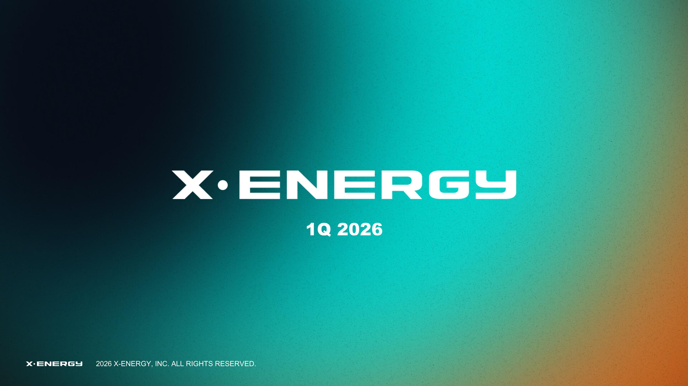
1Q 2026

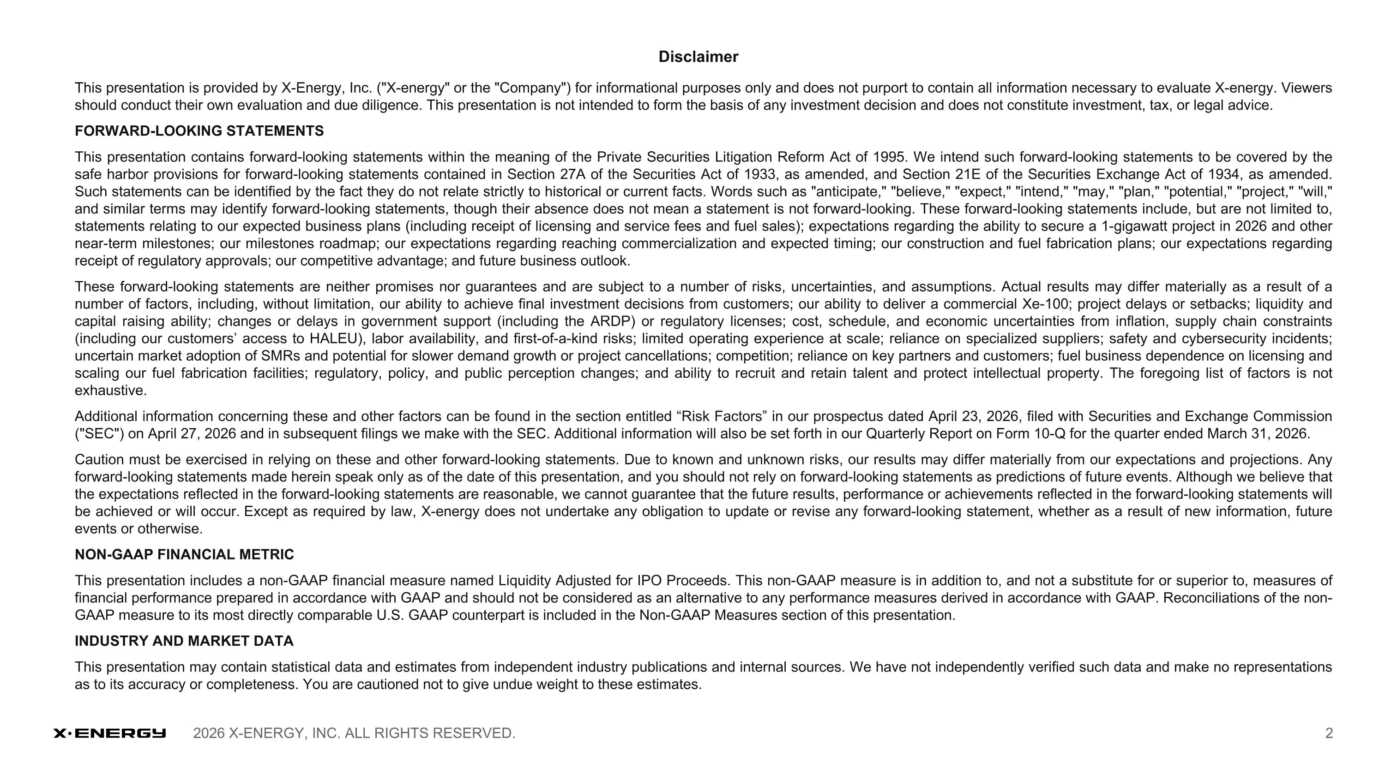
Disclaimer This presentation is provided by X-Energy, Inc. ("X-energy" or the "Company") for informational purposes only and does not purport to contain all information necessary to evaluate X-energy. Viewers should conduct their own evaluation and due diligence. This presentation is not intended to form the basis of any investment decision and does not constitute investment, tax, or legal advice. FORWARD-LOOKING STATEMENTS This presentation contains forward-looking statements within the meaning of the Private Securities Litigation Reform Act of 1995. We intend such forward-looking statements to be covered by the safe harbor provisions for forward-looking statements contained in Section 27A of the Securities Act of 1933, as amended, and Section 21E of the Securities Exchange Act of 1934, as amended. Such statements can be identified by the fact they do not relate strictly to historical or current facts. Words such as "anticipate," "believe," "expect," "intend," "may," "plan," "potential," "project," "will," and similar terms may identify forward-looking statements, though their absence does not mean a statement is not forward-looking. These forward-looking statements include, but are not limited to, statements relating to our expected business plans (including receipt of licensing and service fees and fuel sales); expectations regarding the ability to secure a 1-gigawatt project in 2026 and other near-term milestones; our milestones roadmap; our expectations regarding reaching commercialization and expected timing; our construction and fuel fabrication plans; our expectations regarding receipt of regulatory approvals; our competitive advantage; and future business outlook. These forward-looking statements are neither promises nor guarantees and are subject to a number of risks, uncertainties, and assumptions. Actual results may differ materially as a result of a number of factors, including, without limitation, our ability to achieve final investment decisions from customers; our ability to deliver a commercial Xe-100; project delays or setbacks; liquidity and capital raising ability; changes or delays in government support (including the ARDP) or regulatory licenses; cost, schedule, and economic uncertainties from inflation, supply chain constraints (including our customers’ access to HALEU), labor availability, and first-of-a-kind risks; limited operating experience at scale; reliance on specialized suppliers; safety and cybersecurity incidents; uncertain market adoption of SMRs and potential for slower demand growth or project cancellations; competition; reliance on key partners and customers; fuel business dependence on licensing and scaling our fuel fabrication facilities; regulatory, policy, and public perception changes; and ability to recruit and retain talent and protect intellectual property. The foregoing list of factors is not exhaustive. Additional information concerning these and other factors can be found in the section entitled “Risk Factors” in our prospectus dated April 23, 2026, filed with Securities and Exchange Commission ("SEC") on April 27, 2026 and in subsequent filings we make with the SEC. Additional information will also be set forth in our Quarterly Report on Form 10-Q for the quarter ended March 31, 2026. Caution must be exercised in relying on these and other forward-looking statements. Due to known and unknown risks, our results may differ materially from our expectations and projections. Any forward-looking statements made herein speak only as of the date of this presentation, and you should not rely on forward-looking statements as predictions of future events. Although we believe that the expectations reflected in the forward-looking statements are reasonable, we cannot guarantee that the future results, performance or achievements reflected in the forward-looking statements will be achieved or will occur. Except as required by law, X-energy does not undertake any obligation to update or revise any forward-looking statement, whether as a result of new information, future events or otherwise. NON-GAAP FINANCIAL METRIC This presentation includes a non-GAAP financial measure named Liquidity Adjusted for IPO Proceeds. This non-GAAP measure is in addition to, and not a substitute for or superior to, measures of financial performance prepared in accordance with GAAP and should not be considered as an alternative to any performance measures derived in accordance with GAAP. Reconciliations of the non-GAAP measure to its most directly comparable U.S. GAAP counterpart is included in the Non-GAAP Measures section of this presentation. INDUSTRY AND MARKET DATA This presentation may contain statistical data and estimates from independent industry publications and internal sources. We have not independently verified such data and make no representations as to its accuracy or completeness. You are cautioned not to give undue weight to these estimates.

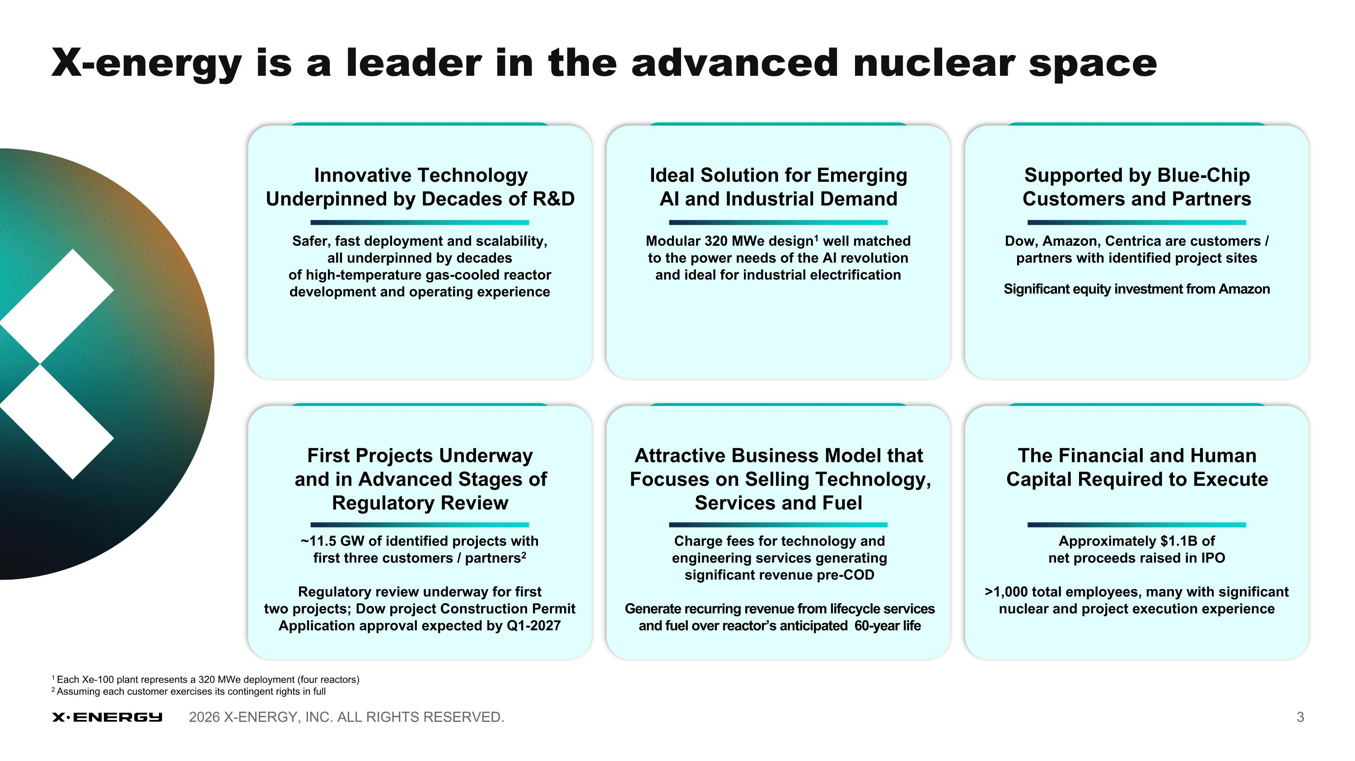
Supported by Blue-Chip Customers and Partners Dow, Amazon, Centrica are customers / partners with identified project sites Significant equity investment from Amazon First Projects Underway and in Advanced Stages of Regulatory Review ~11.5 GW of identified projects with?first three customers / partners2 Regulatory review underway for first ?two projects; Dow project Construction Permit Application approval expected by Q1-2027 Innovative Technology Underpinned by Decades of R&D Safer, fast deployment and scalability, ?all underpinned by decades ?of high-temperature gas-cooled reactor development and operating experience Attractive Business Model that?Focuses on Selling Technology,?Services and Fuel Charge fees for technology and?engineering services generating?significant revenue pre-COD Generate recurring revenue from lifecycle services and fuel over reactor’s anticipated 60-year life Ideal Solution for Emerging AI and Industrial Demand Modular 320 MWe design1 well matched?to the power needs of the AI revolution ?and ideal for industrial electrification The Financial and Human Capital Required to Execute Approximately $1.1B of net proceeds raised in IPO >1,000 total employees, many with significant nuclear and project execution experience X-energy is a leader in the advanced nuclear space 1 Each Xe-100 plant represents a 320 MWe deployment (four reactors) 2 Assuming each customer exercises its contingent rights in full

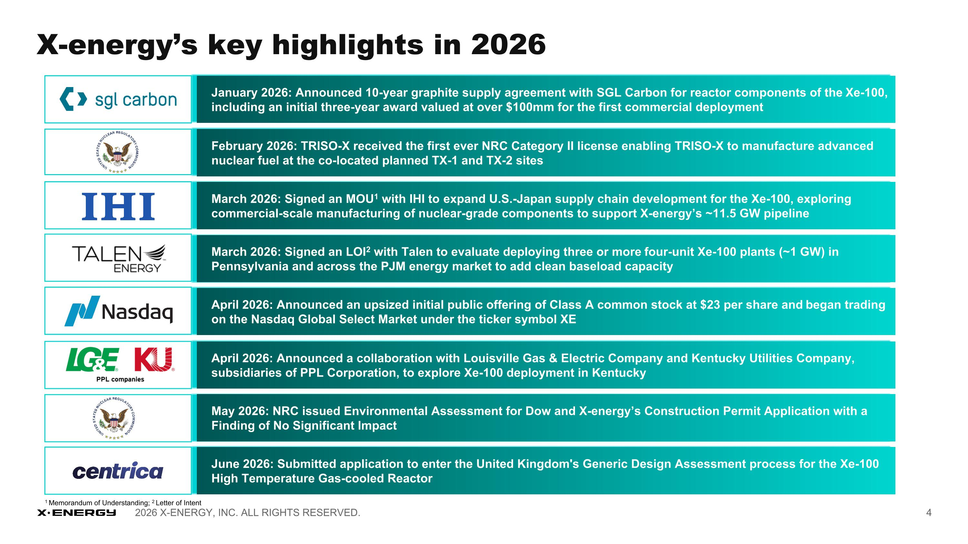
X-energy’s key highlights in 2026 January 2026: Announced 10-year graphite supply agreement with SGL Carbon for reactor components of the Xe-100, including an initial three-year award valued at over $100mm for the first commercial deployment February 2026: TRISO-X received the first ever NRC Category II license enabling TRISO-X to manufacture advanced nuclear fuel at the co-located planned TX-1 and TX-2 sites March 2026: Signed an MOU1 with IHI to expand U.S.-Japan supply chain development for the Xe-100, exploring commercial-scale manufacturing of nuclear-grade components to support X-energy’s ~11.5 GW pipeline March 2026: Signed an LOI2 with Talen to evaluate deploying three or more four-unit Xe-100 plants (~1 GW) in Pennsylvania and across the PJM energy market to add clean baseload capacity 1 Memorandum of Understanding; 2 Letter of Intent April 2026: Announced an upsized initial public offering of Class A common stock at $23 per share and began trading on the Nasdaq Global Select Market under the ticker symbol XE April 2026: Announced a collaboration with Louisville Gas & Electric Company and Kentucky Utilities Company, subsidiaries of PPL Corporation, to explore Xe-100 deployment in Kentucky May 2026: NRC issued Environmental Assessment for Dow and X-energy’s Construction Permit Application with a Finding of No Significant Impact June 2026: Submitted application to enter the United Kingdom's Generic Design Assessment process for the Xe-100 High Temperature Gas-cooled Reactor

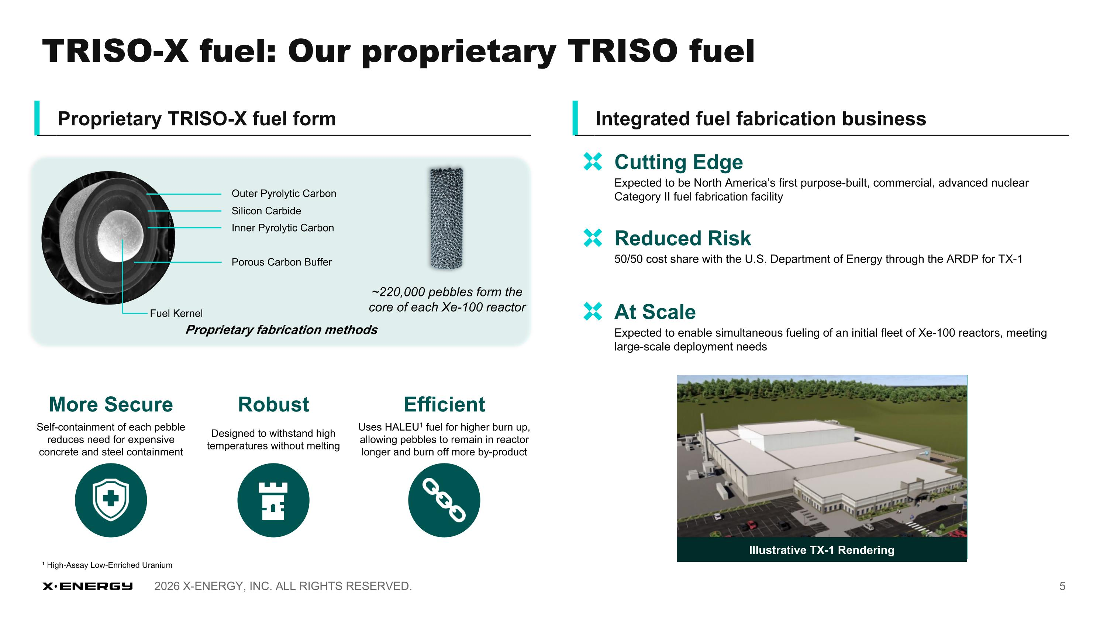
~220,000 pebbles form the core of each Xe-100 reactor Proprietary TRISO-X fuel form Integrated fuel fabrication business Illustrative TX-1 Rendering Outer Pyrolytic Carbon Silicon Carbide Inner Pyrolytic Carbon Porous Carbon Buffer Fuel Kernel Proprietary fabrication methods More Secure Self-containment of each pebble reduces need for expensive concrete and steel containment Robust Designed to withstand high temperatures without melting Efficient Uses HALEU1 fuel for higher burn up, allowing pebbles to remain in reactor longer and burn off more by-product ¹ High-Assay Low-Enriched Uranium Expected to be North America’s first purpose-built, commercial, advanced nuclear Category II fuel fabrication facility Cutting Edge 50/50 cost share with the U.S. Department of Energy through the ARDP for TX-1 Reduced Risk Expected to enable simultaneous fueling of an initial fleet of Xe-100 reactors, meeting large-scale deployment needs At Scale TRISO-X fuel: Our proprietary TRISO fuel

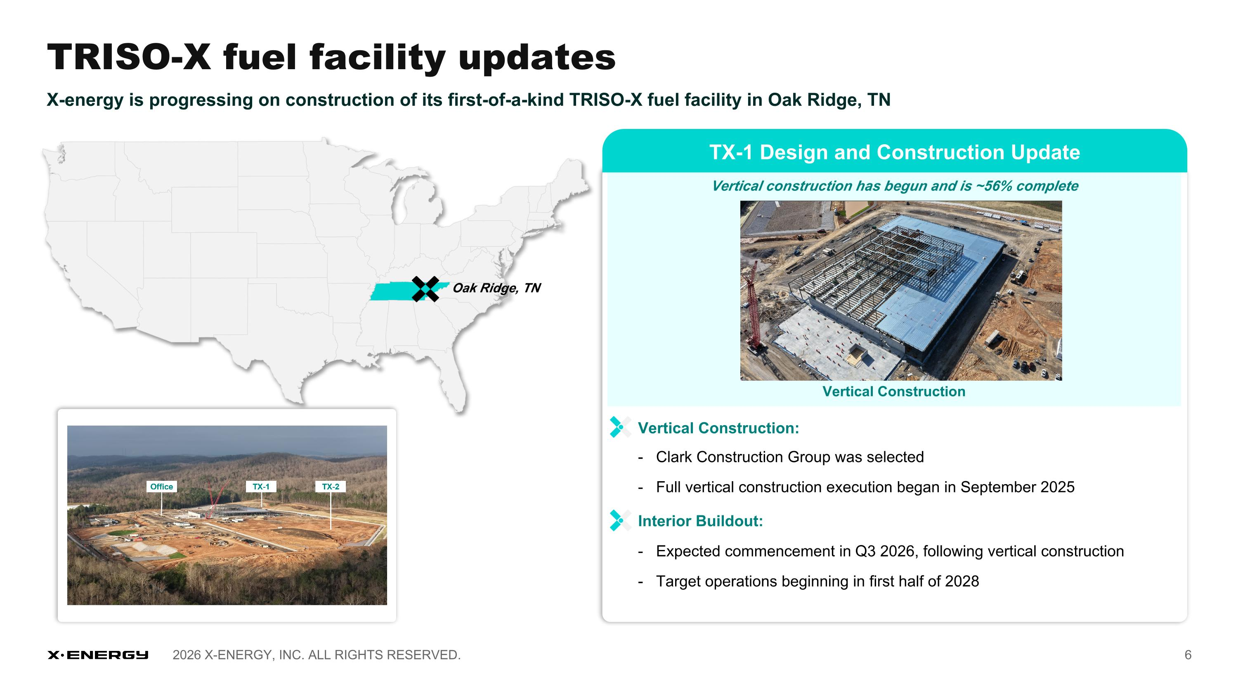
Vertical construction has begun and is ~56% complete Vertical Construction: - Clark Construction Group was selected - Full vertical construction execution began in September 2025 Interior Buildout: - Expected commencement in Q3 2026, following vertical construction - Target operations beginning in first half of 2028 X-energy is progressing on construction of its first-of-a-kind TRISO-X fuel facility in Oak Ridge, TN Oak Ridge, TN TX-1 Design and Construction Update Vertical Construction X-energy is progressing on construction of its first-of-a-kind TRISO-X fuel facility in Oak Ridge, TN TRISO-X fuel facility updates

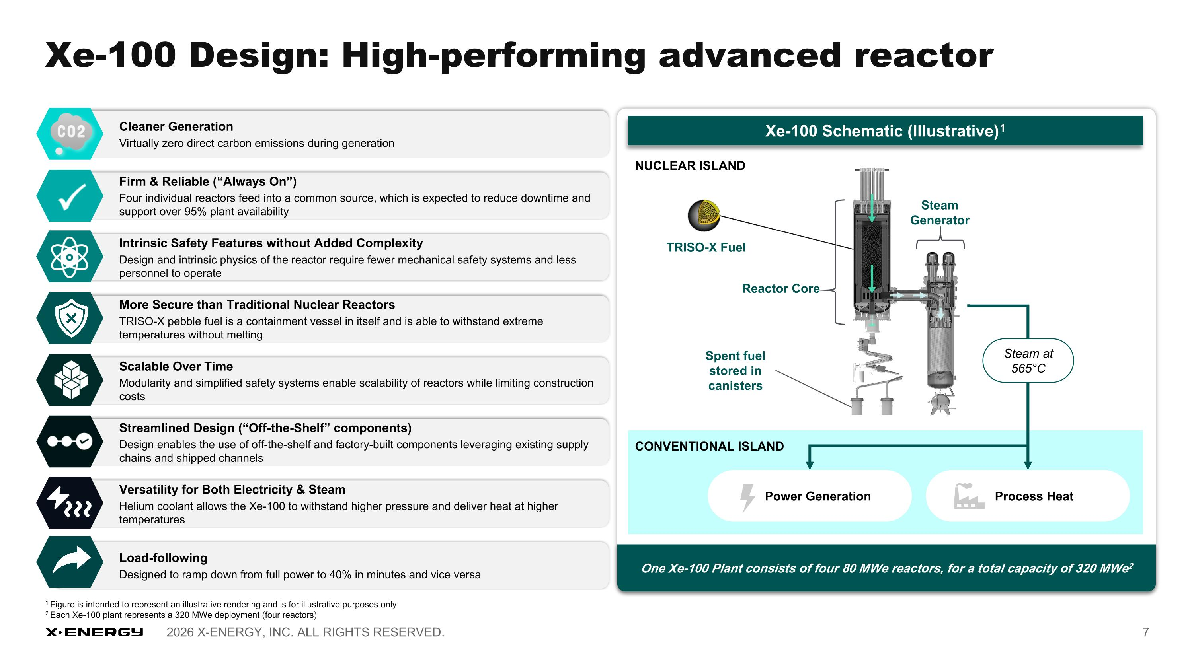
Cleaner Generation Virtually zero direct carbon emissions during generation Scalable Over Time Modularity and simplified safety systems enable scalability of reactors while limiting construction costs Versatility for Both Electricity & Steam Helium coolant allows the Xe-100 to withstand higher pressure and deliver heat at higher temperatures Intrinsic Safety Features without Added Complexity Design and intrinsic physics of the reactor require fewer mechanical safety systems and less personnel to operate Streamlined Design (“Off-the-Shelf” components) Design enables the use of off-the-shelf and factory-built components leveraging existing supply chains and shipped channels Firm & Reliable (“Always On”) Four individual reactors feed into a common source, which is expected to reduce downtime and support over 95% plant availability More Secure than Traditional Nuclear Reactors TRISO-X pebble fuel is a containment vessel in itself and is able to withstand extreme temperatures without melting Load-following Designed to ramp down from full power to 40% in minutes and vice versa 1 Figure is intended to represent an illustrative rendering and is for illustrative purposes only 2 Each Xe-100 plant represents a 320 MWe deployment (four reactors) Engage with Xe-100 Schematic (Illustrative)1 Steam ?Generator TRISO-X Fuel CONVENTIONAL ISLAND Spent fuel stored in canisters Reactor Core NUCLEAR ISLAND Power Generation Process Heat Steam at 565°C One Xe-100 Plant consists of four 80 MWe reactors, for a total capacity of 320 MWe2 Xe-100 Design: High-performing advanced reactor

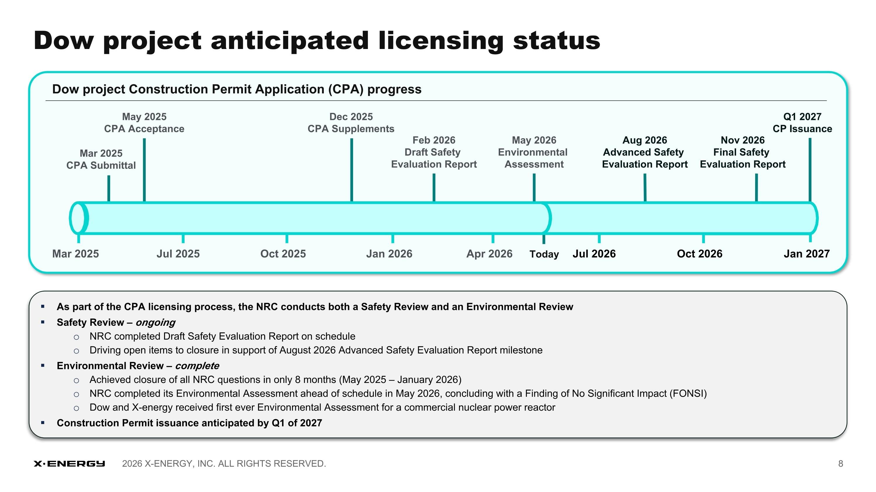
Jan 2027 Mar 2025 Jul 2025 Oct 2025 Jan 2026 Apr 2026 Jul 2026 Oct 2026 May 2025 CPA Acceptance Mar 2025 CPA Submittal Dec 2025 CPA Supplements Feb 2026 Draft Safety Evaluation Report Today May 2026 Environmental Assessment Aug 2026 Advanced Safety Evaluation Report Nov 2026 Final Safety Evaluation Report Q1 2027 CP Issuance As part of the CPA licensing process, the NRC conducts both a Safety Review and an Environmental Review Safety Review – ongoing NRC completed Draft Safety Evaluation Report on schedule Driving open items to closure in support of August 2026 Advanced Safety Evaluation Report milestone Environmental Review – complete Achieved closure of all NRC questions in only 8 months (May 2025 – January 2026) NRC completed its Environmental Assessment ahead of schedule in May 2026, concluding with a Finding of No Significant Impact (FONSI) Dow and X-energy received first ever Environmental Assessment for a commercial nuclear power reactor Construction Permit issuance anticipated by Q1 of 2027 Dow project anticipated licensing status Dow project Construction Permit Application (CPA) progress

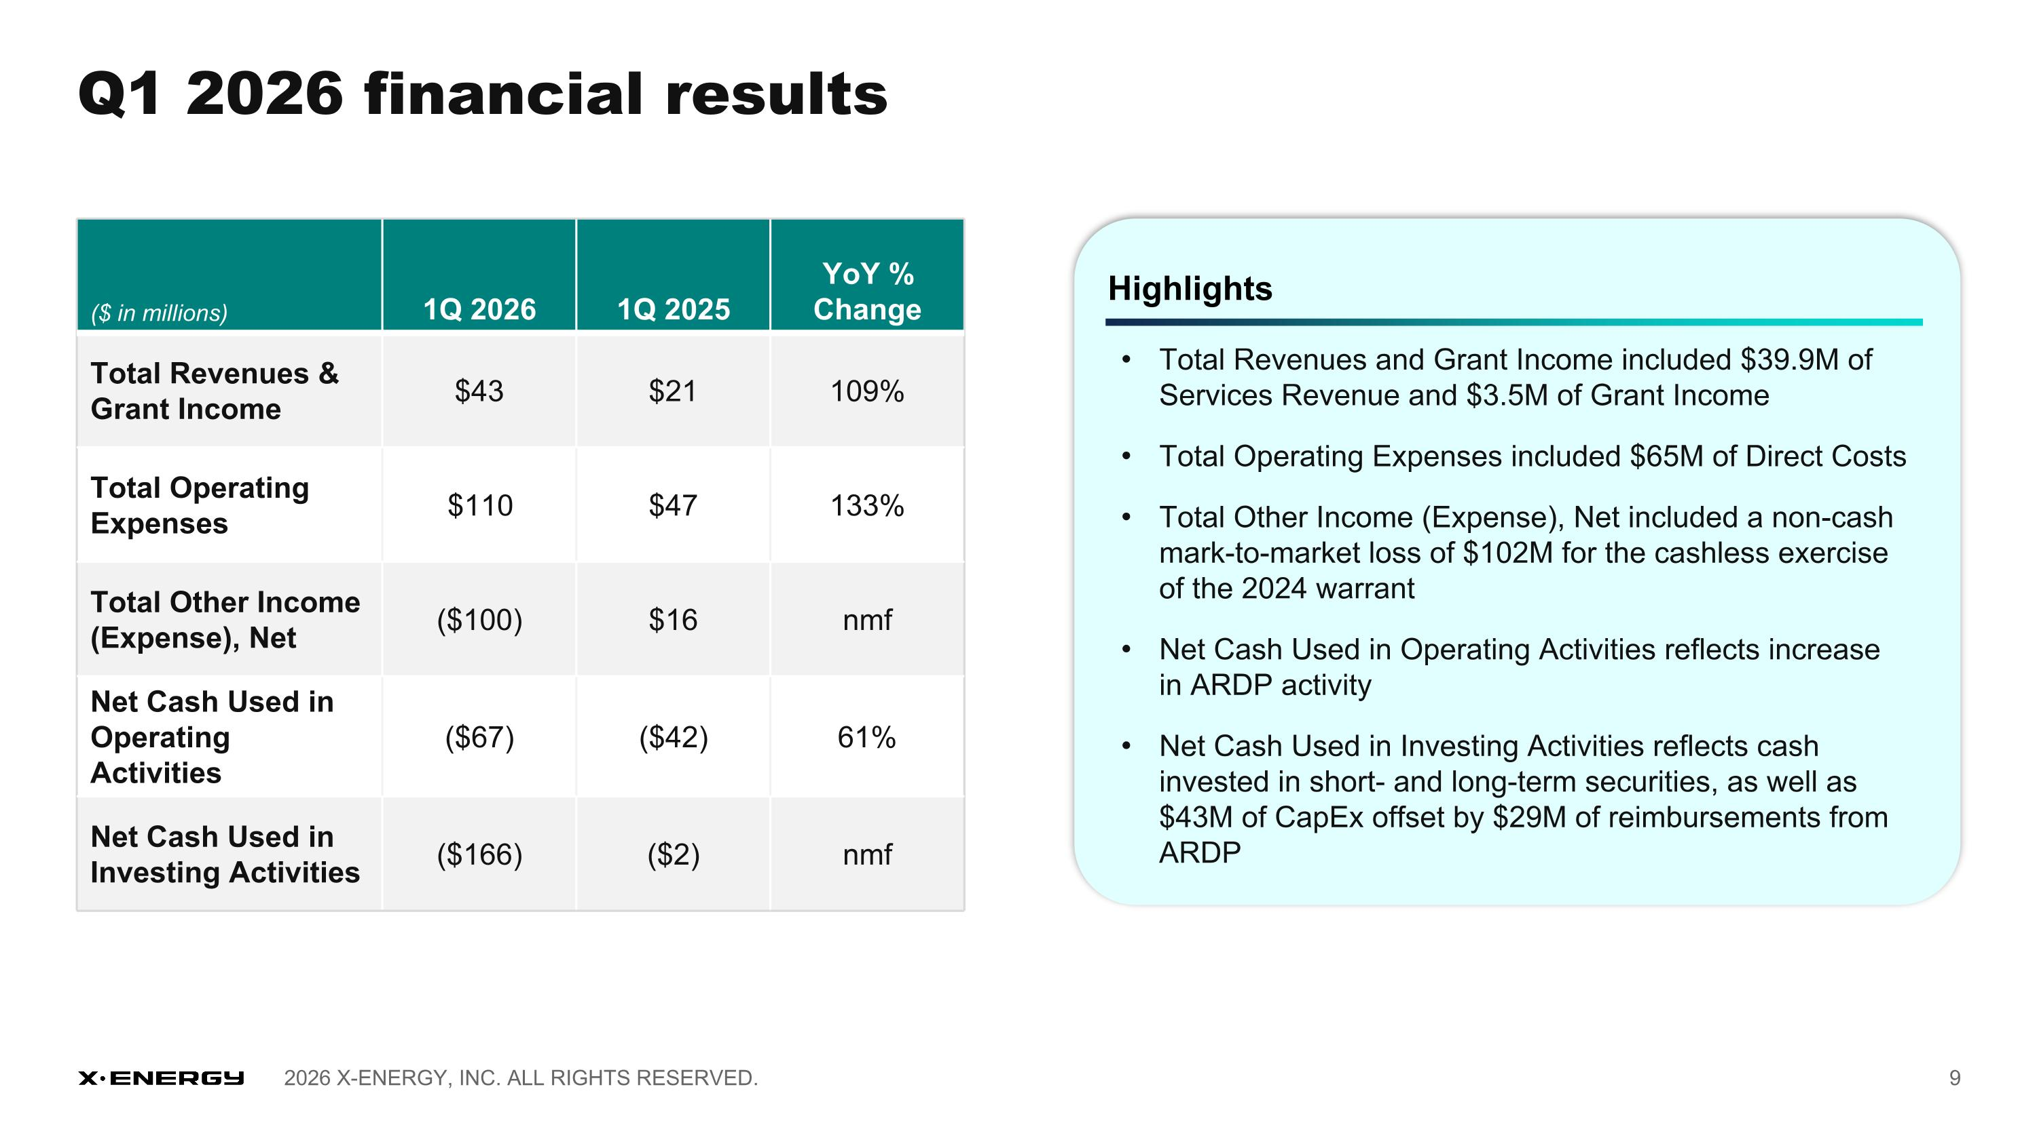
Q1 2026 financial results ($ in millions) 1Q 2026 1Q 2025 YoY % Change Total Revenues & Grant Income $43 $21 109% Total Operating Expenses $110 $47 133% Total Other Income (Expense), Net ($100) $16 nmf Net Cash Used in Operating Activities ($67) ($42) 61% Net Cash Used in Investing Activities ($166) ($2) nmf Highlights Total Revenues and Grant Income included $39.9M of Services Revenue and $3.5M of Grant Income Total Operating Expenses included $65M of Direct Costs Total Other Income (Expense), Net included a non-cash mark-to-market loss of $102M for the cashless exercise of the 2024 warrant Net Cash Used in Operating Activities reflects increase in ARDP activity Net Cash Used in Investing Activities reflects cash invested in short- and long-term securities, as well as $43M of CapEx offset by $29M of reimbursements from ARDP

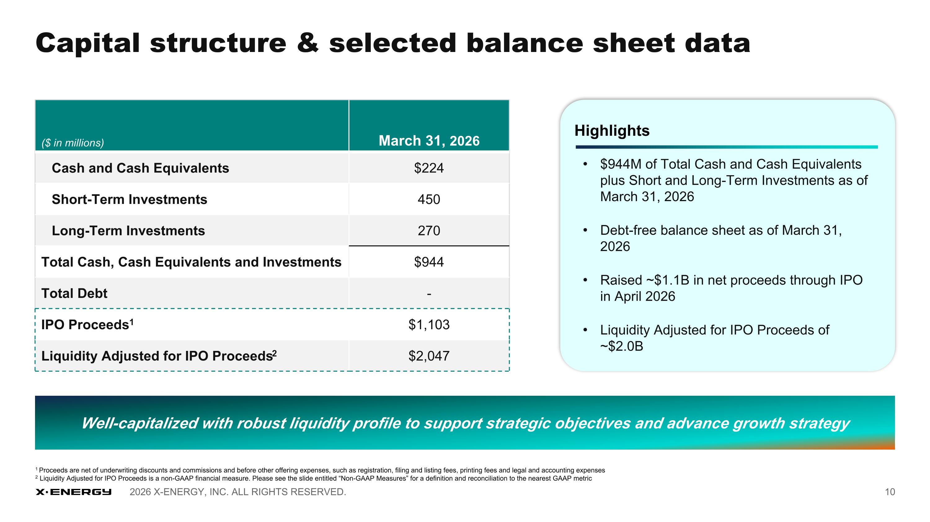
Capital structure & selected balance sheet data ($ in millions) March 31, 2026 Cash and Cash Equivalents $224 Short-Term Investments 450 Long-Term Investments 270 Total Cash, Cash Equivalents and Investments $944 Total Debt - IPO Proceeds1 $1,103 Liquidity Adjusted for IPO Proceeds2 $2,047 Well-capitalized with robust liquidity profile to support strategic objectives and advance growth strategy Highlights $944M of Total Cash and Cash Equivalents plus Short and Long-Term Investments as of March 31, 2026 Debt-free balance sheet as of March 31, 2026 Raised ~$1.1B in net proceeds through IPO in April 2026 Liquidity Adjusted for IPO Proceeds of ~$2.0B 1 Proceeds are net of underwriting discounts and commissions and before other offering expenses, such as registration, filing and listing fees, printing fees and legal and accounting expenses 2 Liquidity Adjusted for IPO Proceeds is a non-GAAP financial measure. Please see the slide entitled “Non-GAAP Measures” for a definition and reconciliation to the nearest GAAP metric

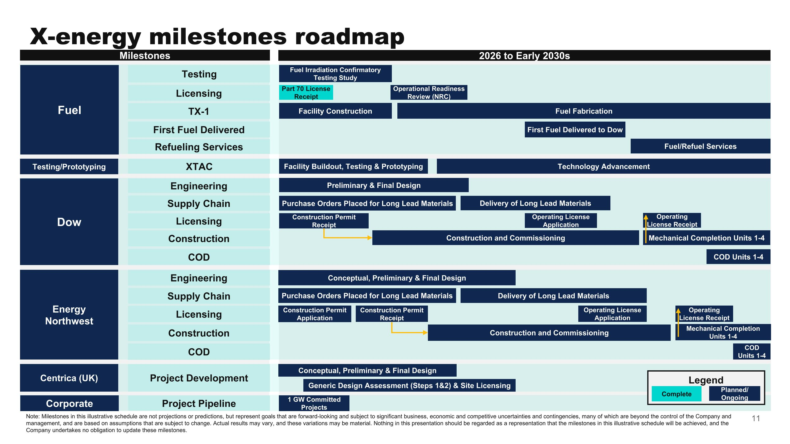
Note: Milestones in this illustrative schedule are not projections or predictions, but represent goals that are forward-looking and subject to significant business, economic and competitive uncertainties and contingencies, many of which are beyond the control of the Company and management, and are based on assumptions that are subject to change. Actual results may vary, and these variations may be material. Nothing in this presentation should be regarded as a representation that the milestones in this illustrative schedule will be achieved, and the Company undertakes no obligation to update these milestones. Fuel Dow Milestones Testing 2026 to Early 2030s 1 GW Committed Projects Licensing TX-1 First Fuel Delivered Refueling Services Testing/Prototyping XTAC Engineering Supply Chain Licensing Construction COD Energy Northwest Engineering Supply Chain Licensing Construction COD Centrica (UK) Project Development Corporate Project Pipeline Operational Readiness Review (NRC) Fuel Irradiation Confirmatory Testing Study Part 70 License Receipt Facility Construction Fuel Fabrication First Fuel Delivered to Dow Fuel/Refuel Services Facility Buildout, Testing & Prototyping Technology Advancement Preliminary & Final Design Purchase Orders Placed for Long Lead Materials Delivery of Long Lead Materials Construction Permit Receipt Construction and Commissioning Operating License Application Mechanical Completion Units 1-4 Operating License Receipt COD Units 1-4 Conceptual, Preliminary & Final Design Purchase Orders Placed for Long Lead Materials Delivery of Long Lead Materials Construction Permit Application Construction Permit Receipt Construction and Commissioning Operating License Application Mechanical Completion Units 1-4 Operating License Receipt COD Units 1-4 Conceptual, Preliminary & Final Design Generic Design Assessment (Steps 1&2) & Site Licensing Planned/ Ongoing Complete Legend X-energy milestones roadmap

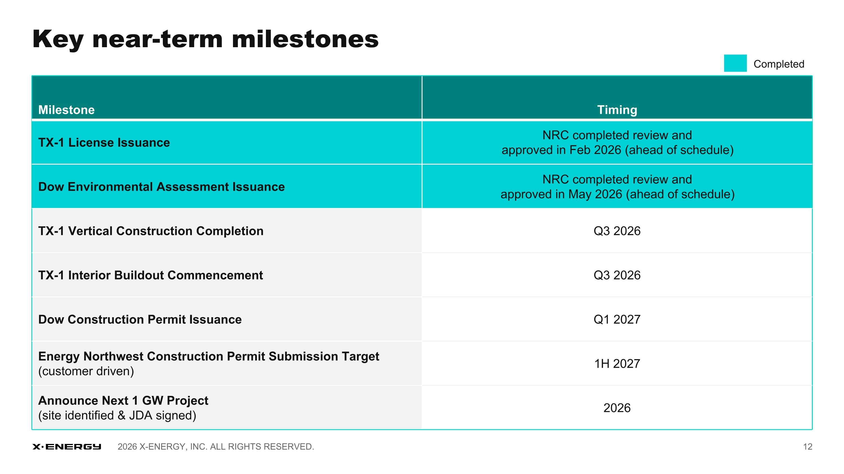
Key near-term milestones Milestone Timing TX-1 License Issuance NRC completed review and approved in Feb 2026 (ahead of schedule) Dow Environmental Assessment Issuance NRC completed review and approved in May 2026 (ahead of schedule) TX-1 Vertical Construction Completion Q3 2026 TX-1 Interior Buildout Commencement Q3 2026 Dow Construction Permit Issuance Q1 2027 Energy Northwest Construction Permit Submission Target (customer driven) 1H 2027 Announce Next 1 GW Project (site identified & JDA signed) 2026 Completed

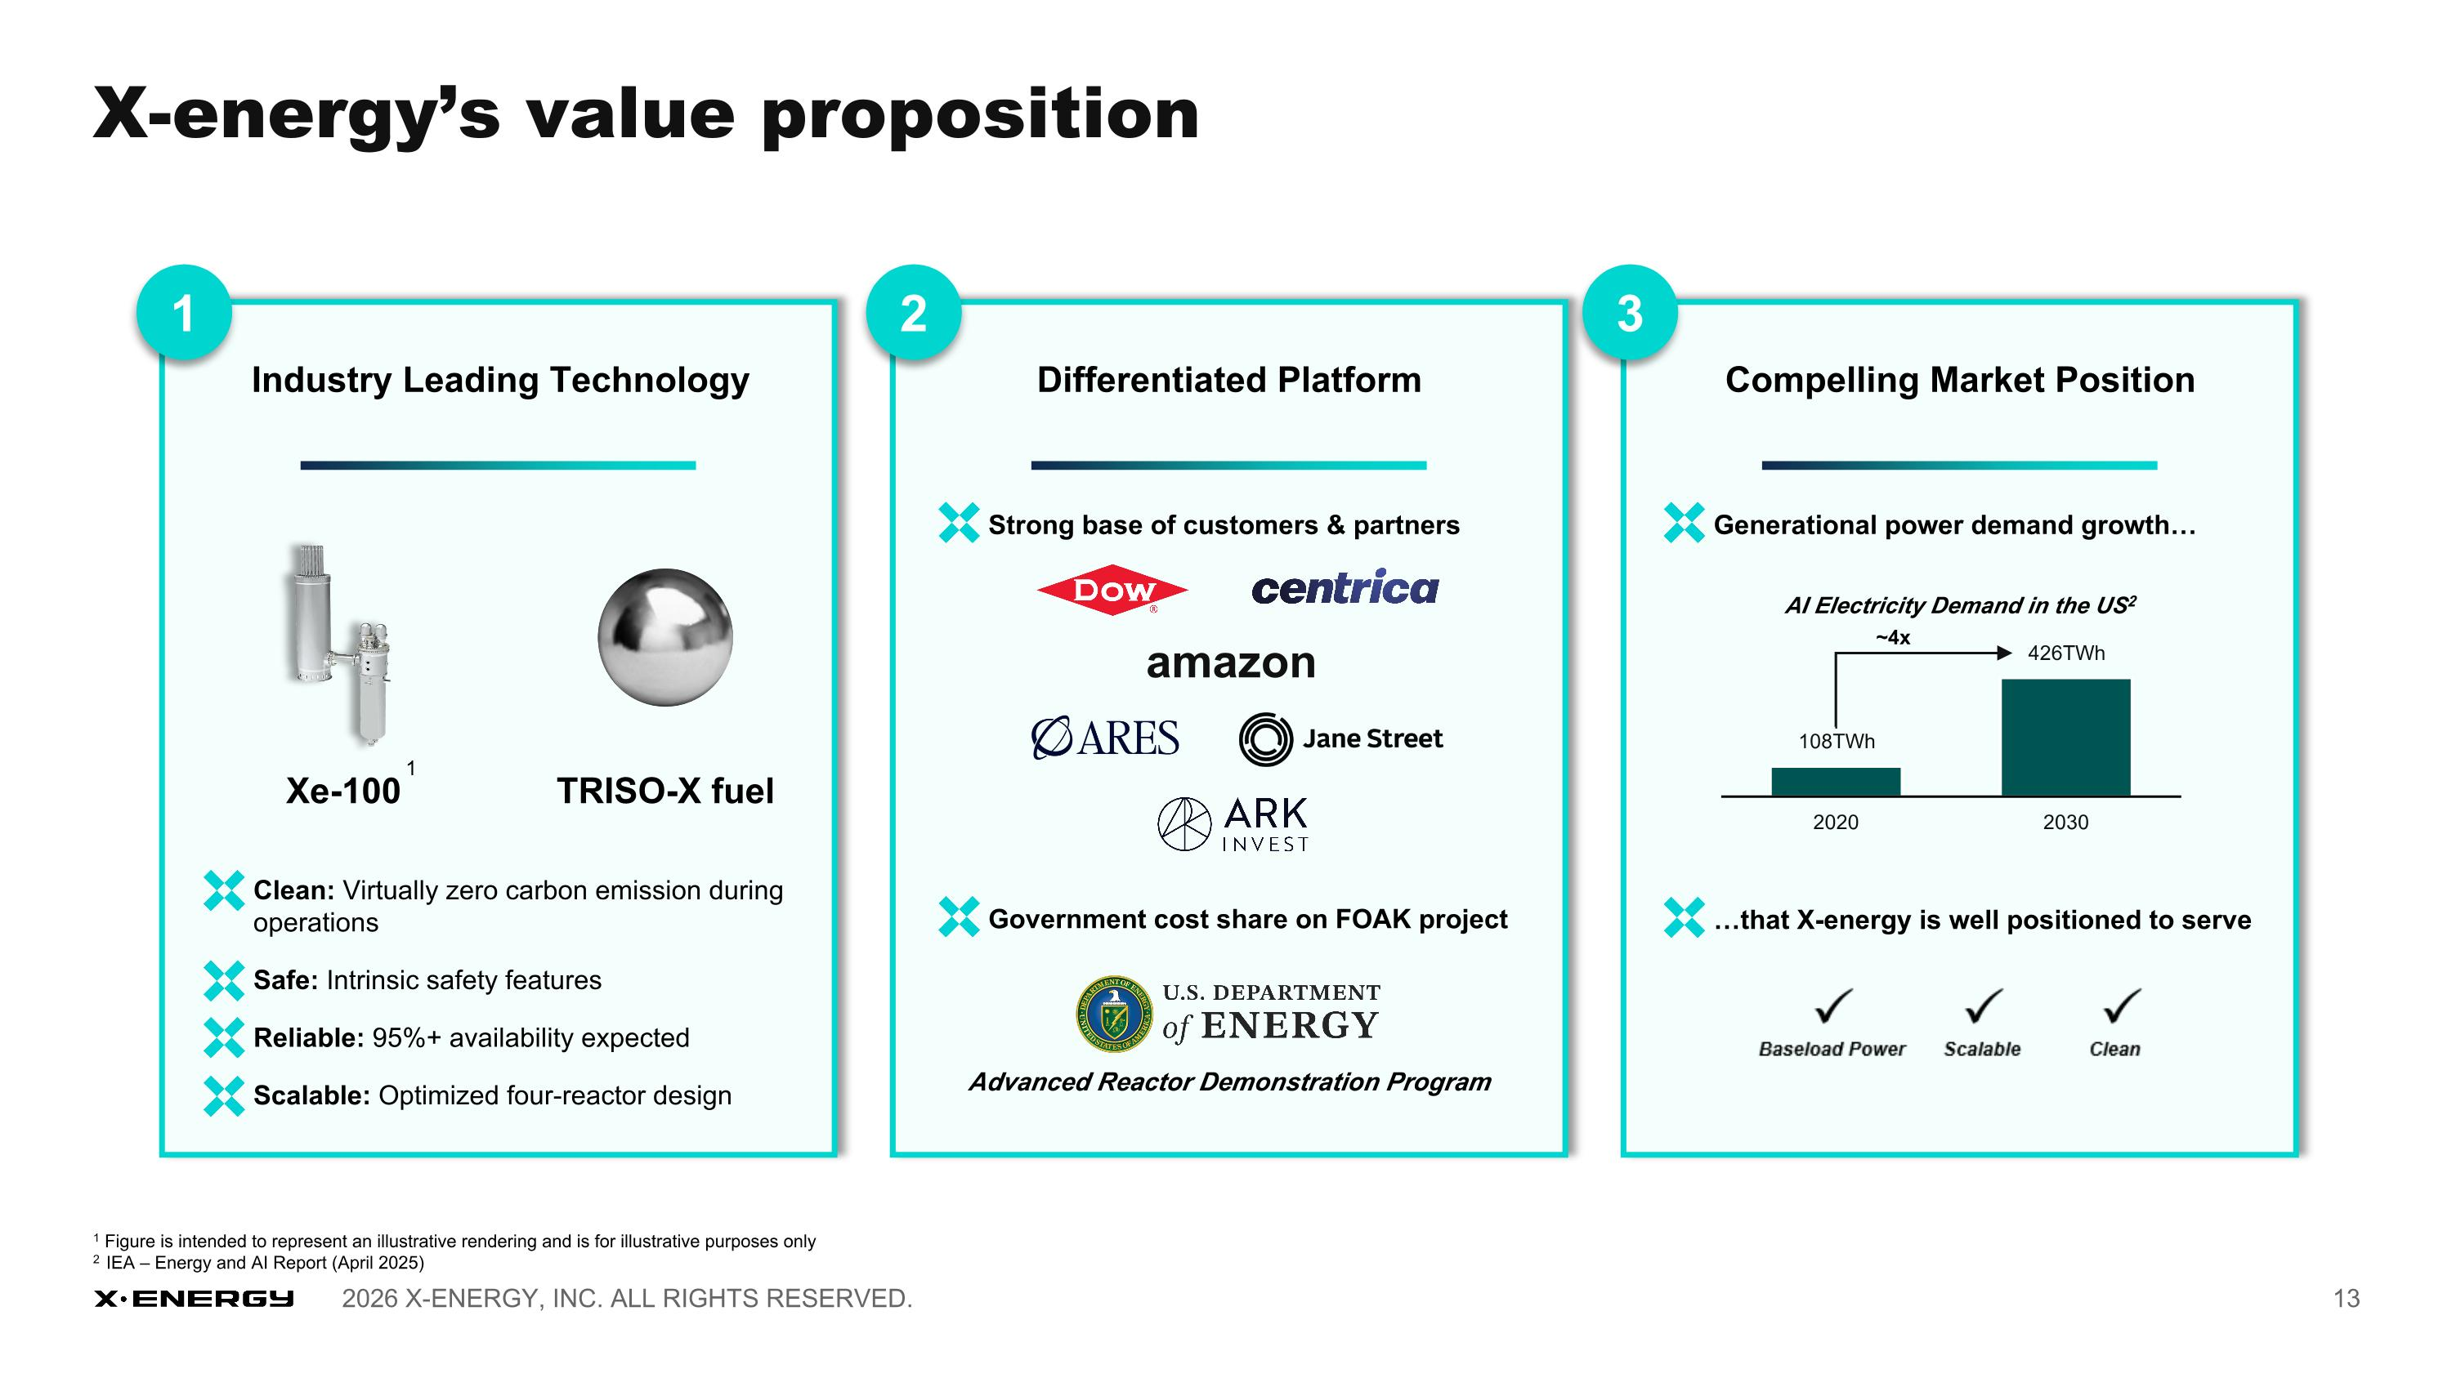
Differentiated Platform 2 Industry Leading Technology Compelling Market Position 3 Clean: Virtually zero carbon emission during operations Safe: Intrinsic safety features Reliable: 95%+ availability expected Scalable: Optimized four-reactor design Xe-100 TRISO-X fuel Strong base of customers & partners Government cost share on FOAK project Advanced Reactor Demonstration Program Generational power demand growth that X-energy is well positioned to serve ~4x AI Electricity Demand in the US2 1 1 Figure is intended to represent an illustrative rendering and is for illustrative purposes only 2 IEA – Energy and AI Report (April 2025) 1 X-energy’s value proposition amazon


Q&A

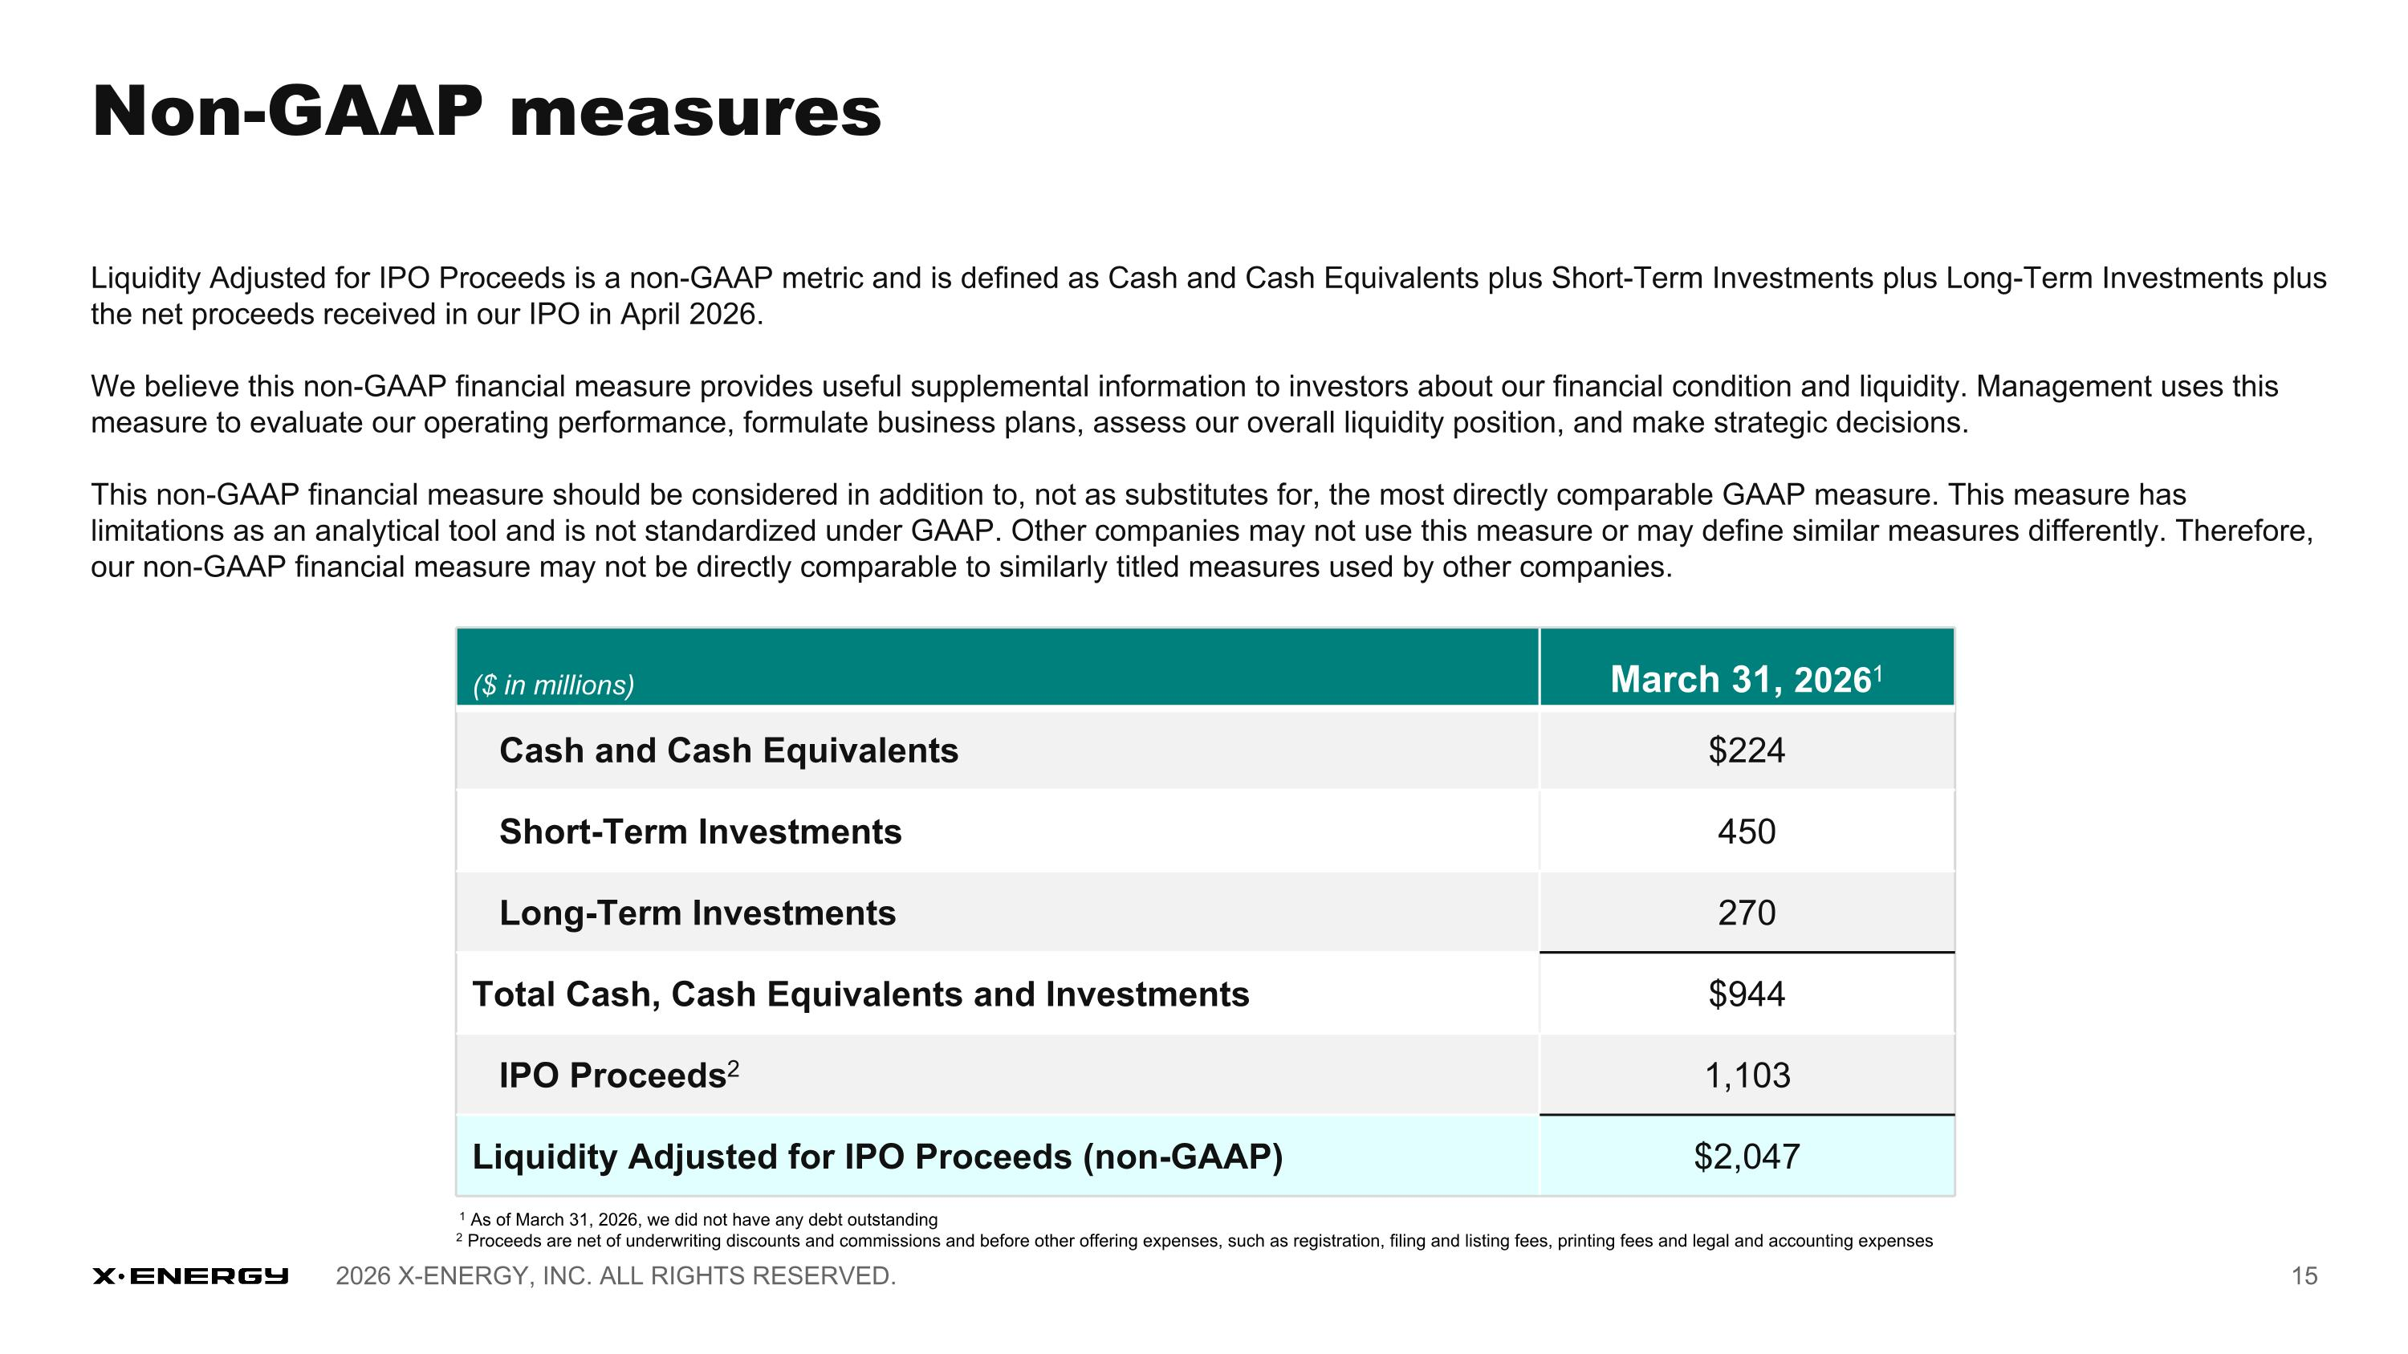
Non-GAAP measures Liquidity Adjusted for IPO Proceeds is a non-GAAP metric and is defined as Cash and Cash Equivalents plus Short-Term Investments plus Long-Term Investments plus the net proceeds received in our IPO in April 2026. We believe this non-GAAP financial measure provides useful supplemental information to investors about our financial condition and liquidity. Management uses this measure to evaluate our operating performance, formulate business plans, assess our overall liquidity position, and make strategic decisions. This non-GAAP financial measure should be considered in addition to, not as substitutes for, the most directly comparable GAAP measure. This measure has limitations as an analytical tool and is not standardized under GAAP. Other companies may not use this measure or may define similar measures differently. Therefore, our non-GAAP financial measure may not be directly comparable to similarly titled measures used by other companies. ($ in millions) March 31, 20261 Cash and Cash Equivalents $224 Short-Term Investments 450 Long-Term Investments 270 Total Cash, Cash Equivalents and Investments $944 IPO Proceeds2 1,103 Liquidity Adjusted for IPO Proceeds (non-GAAP) $2,047 1 As of March 31, 2026, we did not have any debt outstanding 2 Proceeds are net of underwriting discounts and commissions and before other offering expenses, such as registration, filing and listing fees, printing fees and legal and accounting expenses



